**06 - Strings in Python**



**Department of Computer Science and Engineering | Rajalakshmi Engineering College**

**.**

**Ex. No.** **:** **6.1** **Date: 06.05.2024**

**Register No.: 231401100** **Name: Shree Harini S**



**Count Chars**

**Write a python program to count all letters, digits, and special symbols respectively from a given string**

**For example:**

**Input Result**

**rec@123**

**3**

**3**

**1**

**a=input()**

**c,d,s=0,0,0**

**for i in range(len(a)):**

**if(a[i].isalpha()):**

**c+=1**

**elif(a[i].isdigit()):**

**d+=1**

**else:**

**s+=1**

**print(c,d,s,sep="\n")**



**Department of Computer Science and Engineering | Rajalakshmi Engineering College**

**.**

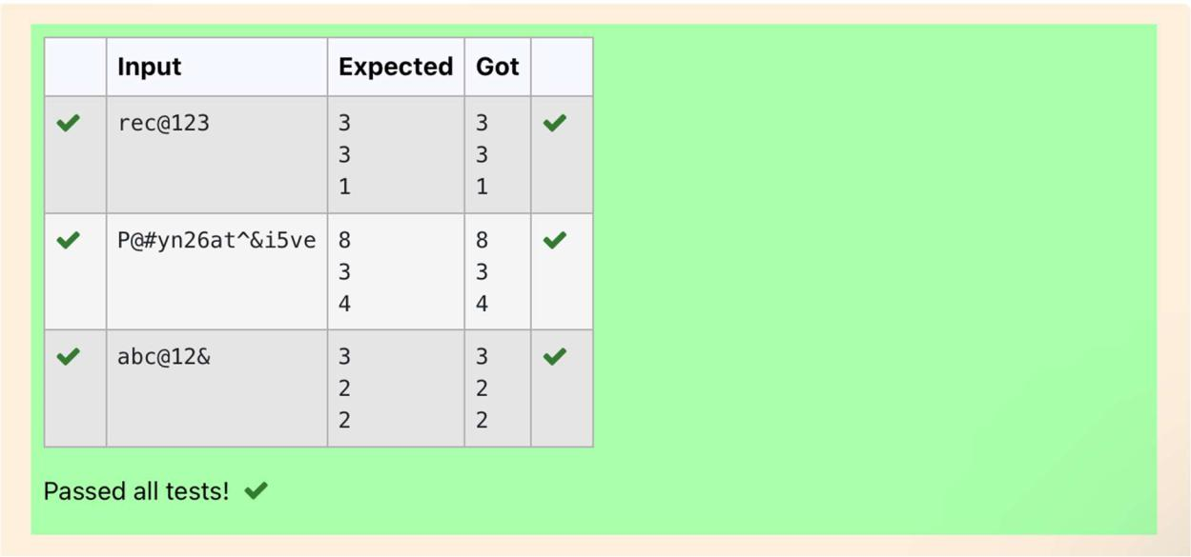

**Department of Computer Science and Engineering | Rajalakshmi Engineering College**

**.**



**Ex. No.** **:** **6.2** **Date: 06.05.2024**

**Register No.: 231401100** **Name: Shree Harini S**



**Decompress the String**

**Assume that the given string has enough memory. Don't use any extra space(IN-PLACE)**

**Sample Input 1**

**a2b4c6**

**Sample Output 1**

**aabbbbcccccc**

**import re**

**a=input()**

**all=re.findall('\d+',a)**

**all_w=re.findall('[a-z]',a)**

**b=''**

**for i,j in zip(all,all_w):**

**b+=int(i)*j**

**print(b)**

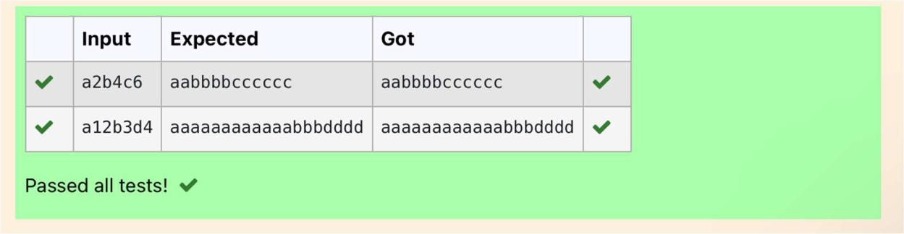

**Department of Computer Science and Engineering | Rajalakshmi Engineering College**

**.**

**Ex. No.** **:** **6.3** **Date: 06.05.2024**

**Register No.: 231401100** **Name: Shree Harini S**



**First N Common Chars**

**Two string values S1, S2 are passed as the input. The program must print first N characters present in S1 which are also present in S2.**

**Input Format:**

**The first line contains S1.**

**The second line contains S2.**

**The third line contains N.**

**Output Format:**

**The first line contains the N characters present in S1 which are also present in S2.**

**Boundary Conditions:**

**2<=N<=10**

**2 <= Length of S1, S2 <= 1000**

**Example Input/Output 1:**

**Input:**

**abcbde**

**cdefghbb**

**3**

**Output:**

**bcd**

**Note:**

**b occurs twice in common but must be printed only once.**

**a=input()**

**b=input()**



**Department of Computer Science and Engineering | Rajalakshmi Engineering College**

**.**

**C=''**

**d=int(input())**

**for i in range(len(a)):**

**if(len(C)-d==0):**

**break**

**else:**

**if(a[i]in b):**

**if(a[i] not in C):**

**C+=a[i]**

**print (C)**

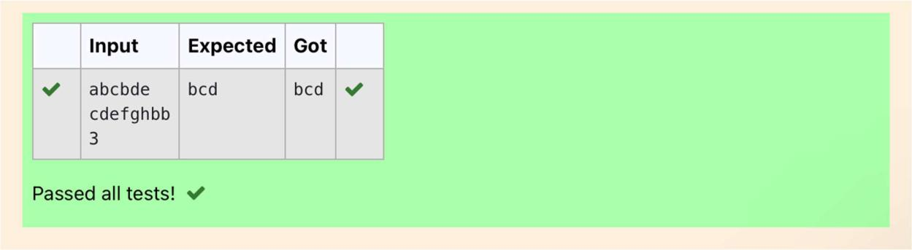

**Department of Computer Science and Engineering | Rajalakshmi Engineering College**

**.**

**Ex. No.** **:** **6.4** **Date: 06.05.2024**

**Register No.: 231401100** **Name: Shree Harini S**



**Remove Characters**

**Given two Strings s1 and s2, remove all the characters from s1 which is present in s2. Constraints**

**1<= string length <= 200**

**Sample Input 1**

**experience**

**enc**

**Sample Output 1**

**xpri**

**def remove_chars(s1, s2):**

**return ''.join([char for char in s1 if char not in s2])**

**s1=input()**

**s2=input()**

**result = remove_chars(s1, s2)**

**print(result)**

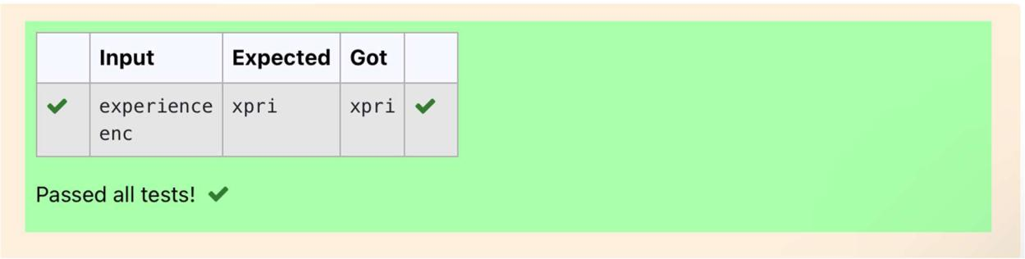

**Department of Computer Science and Engineering | Rajalakshmi Engineering College**

**.**

**Ex. No.** **:** **6.5** **Date:**

**Register No.: 231401100** **Name: Shree Harini S**



**Remove Palindrome Words**

**String should contain only the words are not palindrome.**

**Sample Input 1**

**Malayalam is my mother tongue**

**Sample Output 1**

**is my mother tongue**

**For example:**

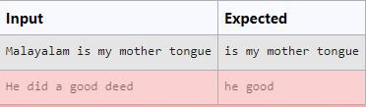

**a=[]**

**a=input()**

**b=a. split()**

**for i in b:**

**k=i.lower()**

**if k!=k[::-1]:**

**print(k,end=' ')**

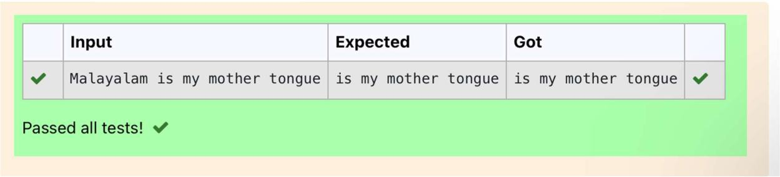

**Department of Computer Science and Engineering | Rajalakshmi Engineering College**

**.**

**Ex. No.** **:** **6.6** **Date: 06.05.2024**

**Register No.: 231401100** **Name: Shree Harini S**



**Return Second World in Uppercase**

**Write a program that takes as input a string (sentence), and returns its second word in uppercase.**

**For example:**

**If input is “Wipro Technologies Bangalore” the function should return “TECHNOLOGIES”**

**If input is “Hello World” the function should return “WORLD” If input is “Hello” the program should return “LESS”**

**NOTE 1: If input is a sentence with less than 2 words, the program should return the word “LESS”.**

**NOTE 2: The result should have no leading or trailing spaces.**

**For example:**

**Input Result**

**Wipro Technologies Bangalore**

**TECHNOLOGIES**

**Hello World**

**WORLD**

**Hello**

**LESS**

**f=input()**

**s=f.split()**

**if len(s)>1:**

**c=s[1]**

**print(c.upper())**

**else:**

**print("LESS")**



**Department of Computer Science and Engineering | Rajalakshmi Engineering College**

**.**

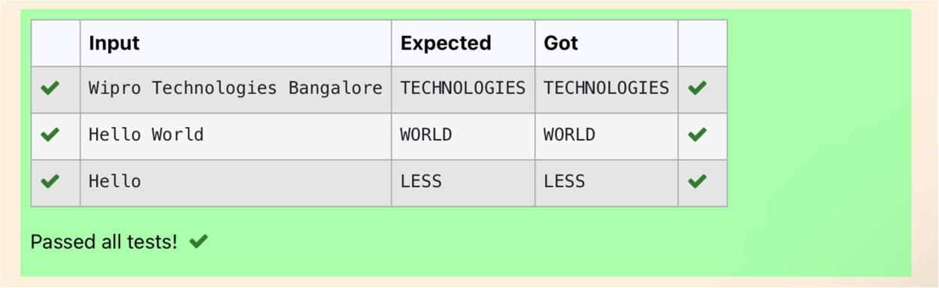

**Department of Computer Science and Engineering | Rajalakshmi Engineering College**

**.**



**Ex. No.** **:** **6.7** **Date: 06.05.2024**

**Register No.: 231401100** **Name: Shree Harini S**



**Revers String**

**Reverse a string without affecting special characters. Given a string S, containing special characters and all the alphabets, reverse the string without affecting the positions of the special characters.**

**Input:**

**A&B**

**Output:**

**B&A**

**Explanation: As we ignore '&' and**

**As we ignore '&' and then reverse, so answer is "B&A".**

**For example:**

**Input Result**

**A&x#**

**x&A#**

**def reverse_string(s):**

**s = list(s)**

**l, r = 0, len(s) - 1**

**while l < r:**

**if not s[l].isalpha():**

**l += 1**

**elif not s[r].isalpha():**

**r -= 1**

**else:**

**s[l], s[r] = s[r], s[l]**

**l += 1**

**r -= 1**

**return ''.join(s)**

**# Test Cases**

**print(reverse_string(input())) # Output: "B&A"**



**Department of Computer Science and Engineering | Rajalakshmi Engineering College**

**.**

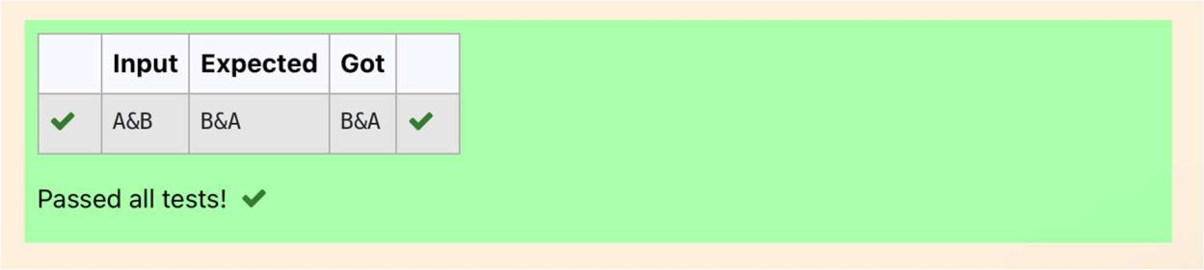

**Department of Computer Science and Engineering | Rajalakshmi Engineering College**

**.**



**Ex. No.** **:** **6.8** **Date: 06.05.2024**

**Register No.: 231401100** **Name: Shree Harini S**



**String characters balance Test**

**Write a program to check if two strings are balanced. For example, strings s1 and s2 are balanced if all the characters in the s1 are present in s2. The character’s position doesn’t matter. If balanced display as "true" ,otherwise "false".**

**For example:**

**Input Result**

**Yn**

**PYnative**

**True**

**a=input()**

**b=input()**

**if a in b:**

**print("True")**

**else:**

**print("False")**

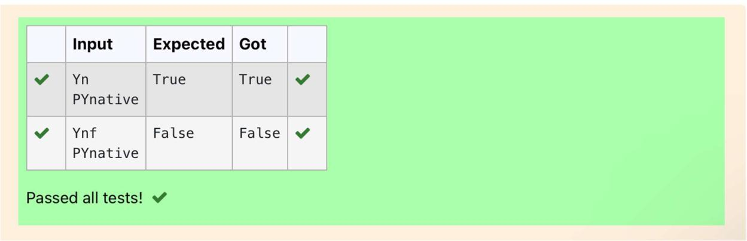

**Department of Computer Science and Engineering | Rajalakshmi Engineering College**

**.**

**Ex. No.** **:** **6.9** **Date: 06.05.2024**

**Register No.: 231401100** **Name: Shree Harini S**



**Unique Names**

**In this exercise, you will create a program that reads words from the user until the user enters a blank line. After the user enters a blank line your program should display each word entered by the user exactly once. The words should be displayed in the same order that they were first entered. For example, if the user enters:**

**Input:**

**first**

**second**

**first**

**third**

**second**

**then your program should display:**

**Output:**

**first**

**second**

**third**

**a,c=[],[]**

**for i in range(0,5):**

**b=input()**

**a.append(b)**

**for i in range(len(a)):**

**if(a[i] not in c):**

**c.append(a[i])**

**print(a[i])**



**Department of Computer Science and Engineering | Rajalakshmi Engineering College**

**.**

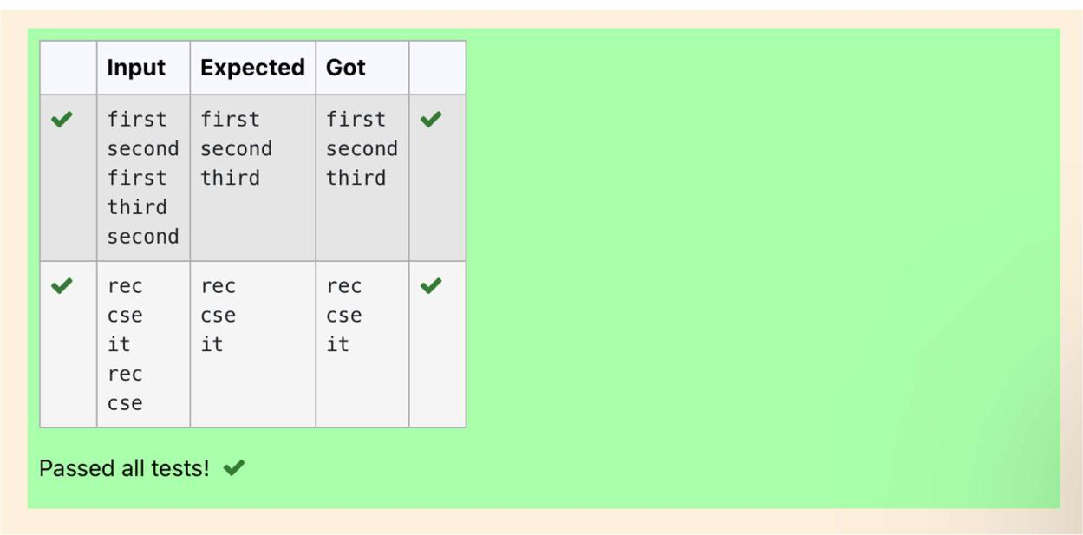

**Department of Computer Science and Engineering | Rajalakshmi Engineering College**

**.**



**Ex. No.** **:** **6.10** **Date: 06.05.2024**

**Register No.: 231401100** **Name: Shree Harini S**



**Username Domain Extension**

**Given a string S which is of the format USERNAME@DOMAIN.EXTENSION, the program must print the EXTENSION, DOMAIN, USERNAME in the reverse order.**

**Input Format:**

**The first line contains S.**

**Output Format:**

**The first line contains EXTENSION.**

**The second line contains DOMAIN.**

**The third line contains USERNAME.**

**Boundary Condition:**

**1 <= Length of S <= 100**

**Example Input/Output 1:**

**Input:**

**vijayakumar.r@rajalakshmi.edu.in**

**Output:**

**edu.in**

**rajalakshmi**

**vijayakumar.r**

**a = input()**

**ext = a.split('@')[0]**

**dom = a.split('@')[1].split('.')[0]**

**userno = a.find('.')**

**user = a[userno+1:]**

**print(user)**



**Department of Computer Science and Engineering | Rajalakshmi Engineering College**

**.**

**print(dom, end='\n')**

**print(ext,end='\n')**

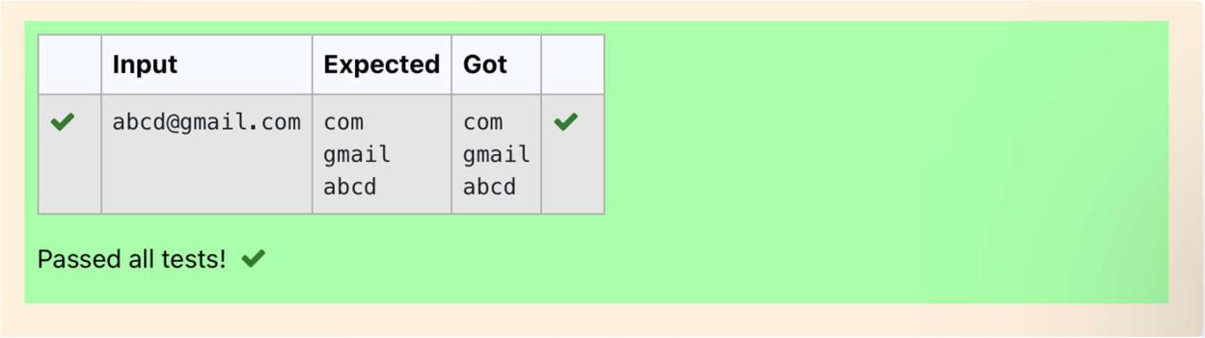

**Department of Computer Science and Engineering | Rajalakshmi Engineering College**

**.**